**SQL ASSIGNMENT – 8**

#### 1) Write an SQL query to fetch intersecting records of two tables.

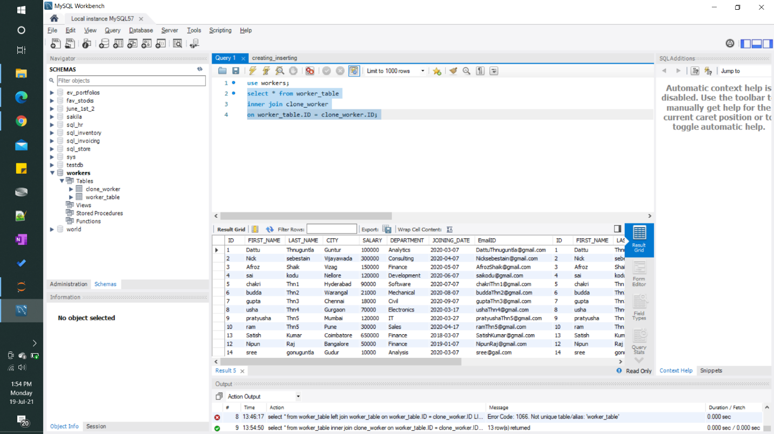

#### 2) Write an SQL query to show records from one table that another table does not have.

#### 